LSU Credit Card
LSU fans should be advised that various companies are marketing this credit card.
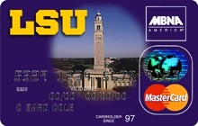
BEWARE… the card comes with les miles and no points!!!!!

