A Great Story…
Have you ever wondered if anyone in Europe remembers America 's sacrifice in World War II? There is an answer in a small town in the Czech Republic. The town is Pilsen ( Plzen ).
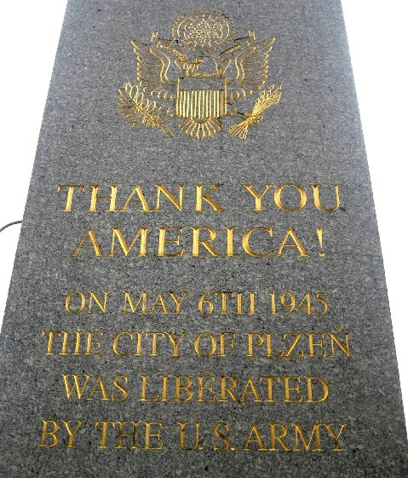
Every 5 years, Pilsen conducts the Liberation Celebration of the City of Pilsen in the CzechRepublic . May 6th, 2010, marked the 65th anniversary of the liberation of Pilsen by General George Patton's 3rd Army. Pilsen is the town that every American should visit. Because they love America and the American Soldier...
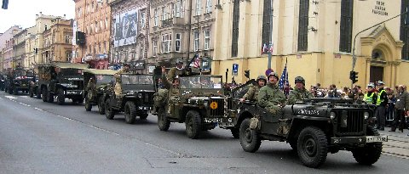
Even 65 years later... by the thousands,
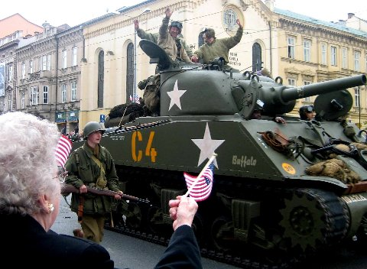
The citizens of Pilsen came to say thank you.

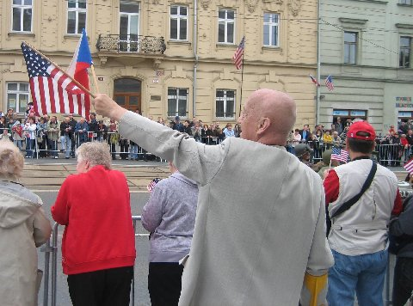
Lining the streets of Pilsen for miles ?
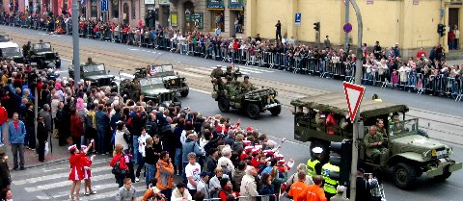
From the large crowds,
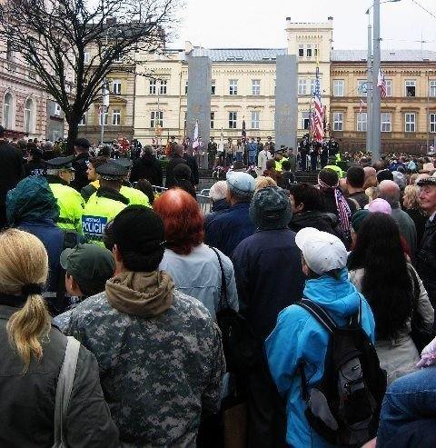

to quiet reflective moments,
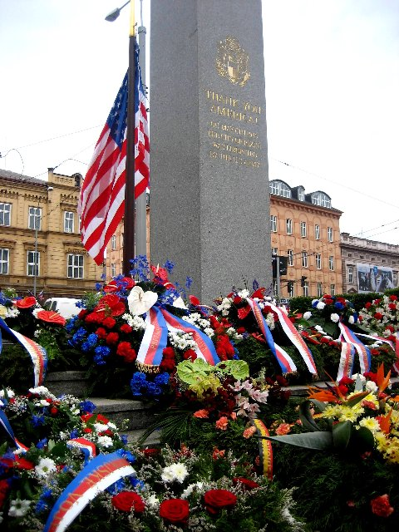

including this American family's private time to honor and remember their American hero.
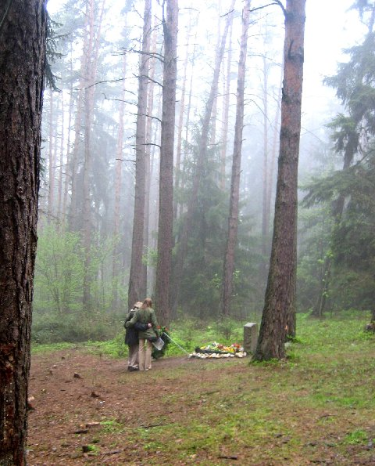
This is the crash site of Lt. Virgil P. Kirkham, the last recorded American USAAF pilot killed in Europe during WWII. It was Lt. Kirkham's 82nd mission and one that he volunteered to go on. At the time, this 20-year-old pilot's P-47 Thunderbolt plane was shot down, a young 14-year-old Czech girl, Zdenka Sladkova, was so moved by his sacrifice she made a vow to care for him and his memory. For 65 straight years, Zdenka, now 79-years-old, took on the responsibility to care for Virgil's crash site and memorial near her home.
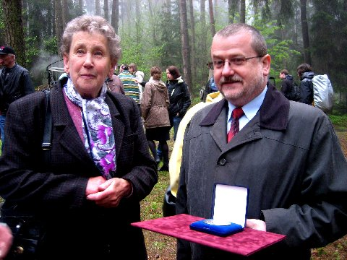

On May 4th, she was recognized by the Mayor of Zdenka's home town of Trhanova , Czech Republic , for her sacrifice and extraordinary effort to honor this American hero.
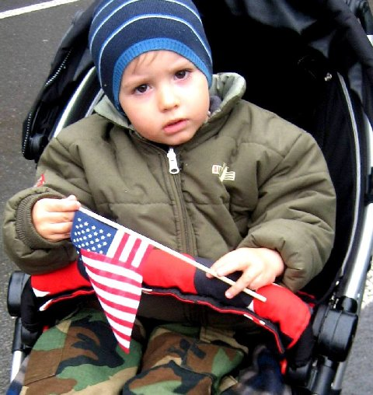
Another chapter in this important story... the Czech people are teaching their children about America's sacrifice for their freedom.
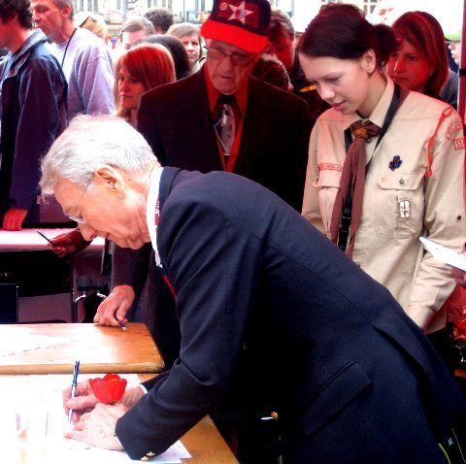

American Soldiers, young and old, are the ''Rock Stars'' these children and their parents want autographs from.
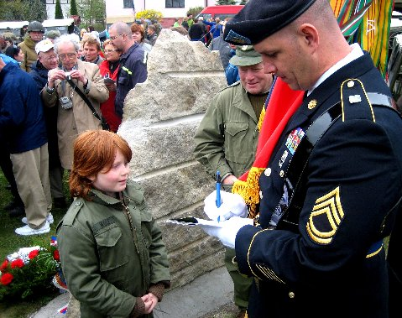
Yes, Rock Stars! As they patiently waited for his autograph, the respect this little Czech boy and his father have for our troops serving today was heartwarming and inspirational.
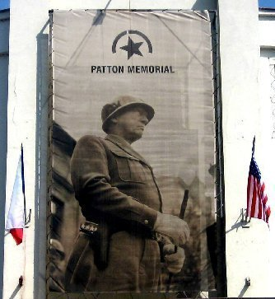

The Brian LaViolette Foundation established The Scholarship of Honor in tribute to General George S. Patton and the American Soldier,past and present.
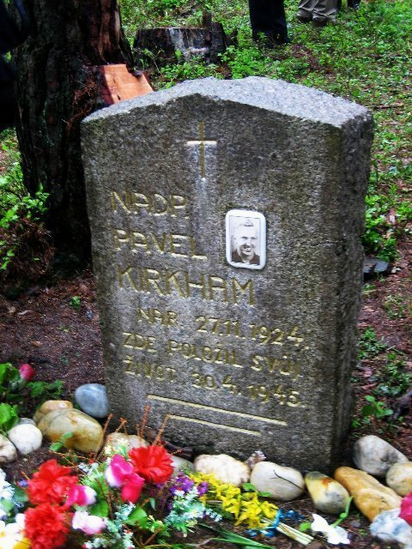
Each year, a different military hero will be honored in tribute to General Patton's memory and their mission to liberate Europe . This award will be presented to a graduating senior who will be entering the military or a form of community service such as fireman, policeman, teaching or nursing -- a cause greater than self. The student will be from 1 of the 5 high schools in Pilsen , Czech Republic .
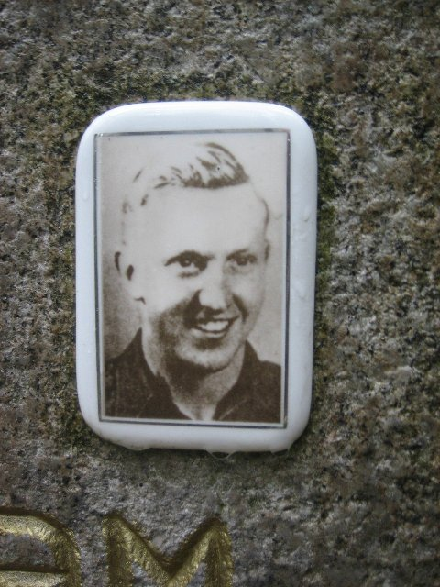
The first award will be presented in May 2011 in honor of Lt. Virgil Kirkham, that young 20-year-old P-47 pilot killed 65 years ago in the final days of WWII.
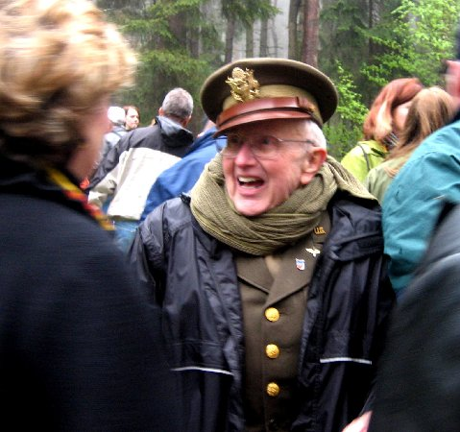
Presenting Virgil's award will be someone who knows the true meaning of service and sacrifice... someone who looks a lot like Virgil. Marion Kirkham, Virgil's brother, who himself served during WWII in the United States Army Air Corps!!!
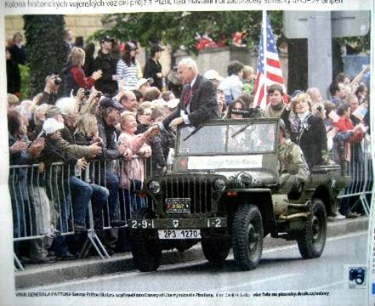
In closing... Here is what the city of Pilsen thinks of General Patton's grandson. George Patton Waters (another Rock Star!) we're proud to say, serves on Brian's Foundation board.
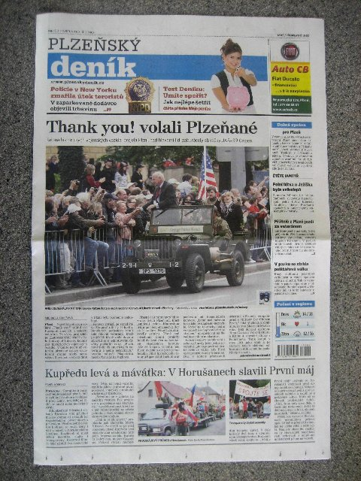
And it's front page news over there? Not buried in the middle of the social section.
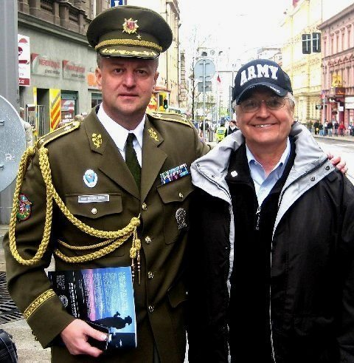
Brigadier General Miroslav Zizka ?1st Deputy Chief of Staff, Ministry of Defense, Czech Armed Forces.
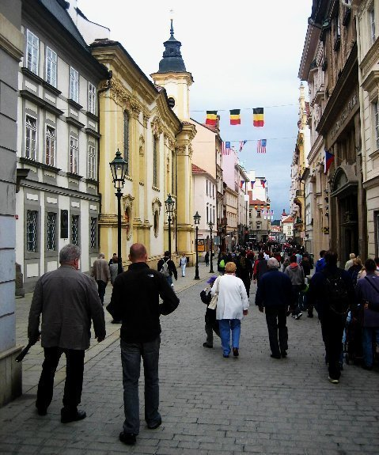
Notice the flags? Share this email with your family and friends ... every American should hear this story.

